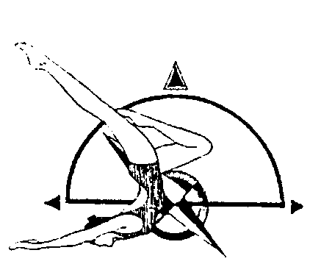
Blossom Invitational
UNITED STATES SYNCHRONIZED SWIMMING,INC.
Pacific Northwest Association

Intermediate, Age Group 12 & Under & Novice Athletes

May 31, 2020
9:00 am – 4:00 pm

MEET
The Blossom Invitational will be held in Kirkland, Washington at the
Juanita High School Pool. It is governed by the 2020 USSS Rules and sanctioned by PNA.

FACILITY
Juanita High School Pool
10601 NE 132nd Street
Kirkland, WA 98416
(425) 936-1627

POOL DIMENSIONS
TBD

HOTEL SUGGESTION
Courtyard by Marriott
11215 NE 124th Street
Kirkland, WA
(425)602-3200

ELIGIBILITY All swimmers must be registered athletes with USSS for the 2019-2020 competition year. Canadian participants welcome as honorary.

REGISTRATION FORMS AND IMPORTANT DATES
Pre Meet Entry Form | N/A | info@seattlesynchro.com
Registration Forms | May 15, 2020 | olga.pastukhova1982@gmail.com  tanakajennifer@gmail.com
Fee Calculation Sheet & Payment | May 15, 2020 | tanakajennifer@gmail.com
Judges Availability Form | May 15, 2020 | princessjackie21@hotmail.com
Coach Credential Form | May 15, 2020 | coachkatleen@seattlesynchro.com

FEES
Sponsor Fee - $15 per competitor
Entry Fee - $10 per competitor per event

VOLUNTEERS

Please wear a white shirt and black bottoms.

FIGURE COMPETITION
Athletes wear black swimsuit and plain white caps. No logos on caps.

NOVICE
101 Ballet Leg Single 1.6
302 Blossom 1.4
361 Prawn 1.5
201 Dolphin 1.4

INTERMEDIATE
101 Ballet Leg Single 1.6
301 Barracuda 1.9
348 Tower 1.9
420 Back Walkover 1.9

12 & UNDER AGE GRP
106 Straight Ballet Leg 1.6
301 Barracuda 1.9
226 Swan 2.1
363 Waterdrop 1.5

ROUTINE COMPETITION
- Intermediate Technical Routines (Duet, Solo, Trio, Team)
- Age Group 12 & U Routines (Duet, Solo, Team, Combo)

Gelling & Degelling
A knoxing area will be provided. De-knoxing is not allowed at pool or in the facility. Any team de-knoxing will incur a $100 fine payable at the time of infraction.

COMPETITION SCHEDULE
A schedule will be available after all entries are received, entered and validated.

CONCESSIONS STAND
Provided by SST

DIGITAL MUSIC SUBMISSIONS
PNA sound equipment will be used including an Ocean Engineering underwater speaker. We will be using DIGITAL MUSIC for routines.
MP3 files are generally much smaller and are better for sending as email attachments. Please indicate in the body of the email how many files are attached; it is also helpful to list the music titles in the email to be sure that all were emailed.

1) We will use a file naming convention, i.e. 13-15AG Duet SST Davis: 13-15AG=routine in entered in the 13-15AG invitational; Duet = Routine event, SST = USA Synchro Club Abbreviation, Davis = last name of the first alphabetical member of the routine.

2) Music is due on no less than 2 weeks before the competition. Minute changes can be made but this will allow plenty of time to have music fully tested and arranged by order of draw.

3) The Sound person will transfer the files from e-mail to a computer file and then import the file to iTunes. The music is tested to ensure it plays.

4) During the week prior to the meet the Scoring Chair e-mails the Start Lists for the Meet to the Technical Chairperson.

5) The Sound person then creates playlists in iTunes for each separate Routine. Please send music to Natalie Montgomery: pnasynchro1@gmail.com

6) At the meet the Sound person uses a laptop and the playlists in iTunes to play the music through the sound system for each Competition.

7) Back up music should still be brought and may be in CD. Back up .mp3 or .wav files may be brought on any standard digital media (memory sticks MP3 Players, etc.)

