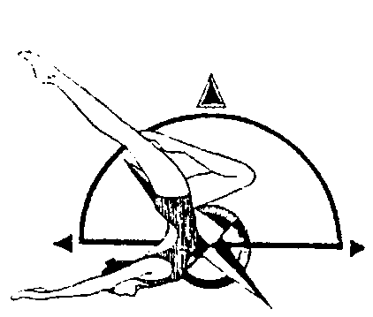
UNITED STATES SYNCHRONIZED SWIMMING,INC.
Pacific Northwest Association

PNA Association Champs

Novice, Intermediate, Age Group, Junior, Senior, Masters

March 18, 2018

8:00 am – 5:00 pm

MEET
The PNA Association Champs will be held in Kirkland, Washington at Juanita High School Aquatic Center. It is governed by the 2018 USSS Rules and sanctioned by PNA.

FACILITY
Juanita Aquatic Center
10601 NE 132nd Street
Kirkland, WA 98034
(425) 936-1627

HOTEL SUGGESTION

Courtyard By Marriott
11215 NE 124th Street
Kirkland, WA 98034
(425)602-3200

ELIGIBILITY
All swimmers must be registered athletes with USSS for the 2017 -2018 competition year. Canadian participants welcome as honorary.

REGISTRATION
Please complete both the Athlete Registration Form & the Judges Availability Form. Entries are due by 3/2/2018.

FEES
Sponsor Fee - $15 per competitor
Entry Fee - $10 per competitor per event

VOLUNTEERS

Please wear a white shirt and black bottoms.

FIGURE COMPETITION
Athletes – wear plain black one piece swimsuit & a plain white cap

NOVICE
101 Ballet Leg Single 1.6
302 Blossom 1.4
361 Prawn 1.5
201 Dolphin 1.4

12 & UNDER AGE GRP
106 Straight Ballet Leg 1.6
301 Barracuda 1.9
226 Swan 2.1
363 Water Drop 1.5

INTERMEDIATE
101 Ballet Leg Single 1.6
301 Barracuda 1.9
360 Walkover Front 1.9
311 Kip 1.6

13 – 15 AGE GRP
423 Ariana 2.2
143 Rio 3.1
355f Porpoise Continuous Spin 720 2.1
315 Seagull 2.1

MASTERS
-To Be Determined

*A DRAW will be done for the other two figures for Masters group on
Wednesday March 14th, 2018. Teams will be notified by email.*

ROUTINE COMPETITION
- Novice Free Routine with Elements (Duet, Solo, Trio, Team)
- Intermediate Free Routines (Duet, Solo, Trio, Team)
- Age Group 12 & U, 13-15, 16-17 & 18-19 Free Routines (Duet, Solo, Team, Combo)
- Masters Free Routines (Solo, Duet, Trio, Team)
- Age Group 16-17, 18-19 & Masters Technical Routines (Duet, Solo, Team)
SCHEDULE
A schedule will be available after all entries are received, entered and validated.

DIGITAL MUSIC SUBMISSIONS
PNA sound equipment will be used including an Ocean Engineering underwater speaker. We will be using DIGITAL MUSIC for routines.

The Rocky Mountain Association has been using Digital Music for all Routine music at its local meets since the 2007-08 season. We also want to use Digital Music files for our PNA competitions. These instructions come from them, on “how they do it”. If you are interested in taking the stress out of the competition, please follow the directions and let’s see how it goes. Digital Music is simply taking an MP3, WAV or other comparable music file and putting it on a laptop computer and using iTunes to play the music at our meets. MP3 files are generally much smaller and are better for sending as email attachments. Please indicate in the body of the email how many files are attached; it is also helpful to list the music titles in the email to be sure that all were emailed.

1) We will use a file naming convention, i.e. 13-15AG Duet SST Davis: 13-15AG=routine in entered in the 13-15AG invitational; Duet = Routine event, SST = USA Synchro Club Abbreviation, Davis = last name of the first alphabetical member of the routine.

2) Music is due on no less than 2 weeks before the competition. Minute changes can be made but this will allow plenty of time to have music fully tested and arranged by order of draw.

3) The Sound person will transfer the files from e-mail to a computer file and then import the file to iTunes. The music is tested to ensure it plays.

4) During the week prior to the meet the Scoring Chair e-mails the Start Lists for the Meet to the Technical Chairperson.

5) The Sound person then creates playlists in iTunes for each separate Routine. Please send music to Natalie Montgomery: pnasynchro1@gmail.com

6) At the meet the Sound person uses a laptop and the playlists in iTunes to play the music through the sound system for each Competition.

7) Back up music should still be brought and may be in CD. Back up .mp3 or .wav files may be brought on any standard digital media (memory sticks MP3 Players, etc.)

**A Concession Stand will be provided by Seattle Synchro**

